(Approx. 831 words)

Viewing the Bigger Picture
By Bonnie L. Snyder, P*PCompAS, Colorado Springs, CO
http://ppcompas.apcug.org/
Bonniels21(at)gmail.com

Obtained from APCUG with the author's permission for publication by APCUG member groups.

At the risk of being the bearer of bad news, I have to say that none of us is getting any younger. User groups tend to be populated more by senior citizens than by any other age group. As we age, we find the need for more and more assistive aids, including those that will help us to use our computers more comfortably and efficiently.

Many of us will find, as time goes on, that our vision is not what it used to be. We may find that our eyes fatigue as we read information on the computer monitor, and we may find that some of the smaller fonts and graphics on the screen require us to squint and lean forward into the display.

In this article, I will discuss two screen enlargement programs that might help us minimize our visual difficulties as we use our computers.

The first program I want to talk about is called Magic Lens Max. I downloaded an older version of the program from Giveawayoftheday.com and was very impressed with what it could do. I e-mailed the program’s author and told him what a terrific program it was and I have demonstrated it to various groups who provide services to the blind and visually impaired. Additionally, the cost of the program is only $39.95. I went ahead and purchased a copy of the most recent edition and was even more pleased with what the author had added since my downloaded version.

Magic Lens Max provides a variety of ways to magnify the computer screen, from resizable moveable lenses, which magnify directly over where your mouse or cursor is working, to a full screen magnification option, which slows down the screen refresh very minimally. You have some color contrast options to choose from with this program as well as an invert colors option for light text on dark background. The magnification levels can be selected from 50% (which is non-magnification) up to pretty much infinity. Anything above 350% starts to blur a bit, although there are options to sharpen. Below is the Magic Lens Max option screen:

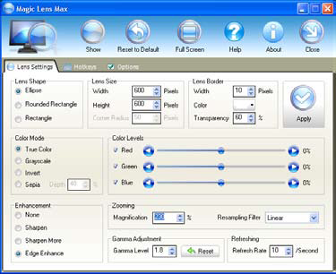

The Magic Lens Max icon that resides in the system tray can be single-clicked to turn on or turn off the magnification.

This is an excellent program that is both useful and affordable. If you are interested in testing it out, go to www.visionsuit.com. You can download a 30-day demo of the latest version. If you decide to purchase Magic Lens Max, once you have paid the $39.95, you will be sent a registration code that can be entered into the demo, and it becomes fully functional.

The second program I evaluated for screen magnification allows for an additional option: speech along with the magnification. This program is called iZoom, and can be obtained from http://www.issist.com/. I really like the customizing options available in iZoom. These can be accessed from the initial menu when iZoom comes on, or once the menu is closed, you can reopen it quickly by clicking the mouse on the iZoom icon in the system tray. Here are the option screens:

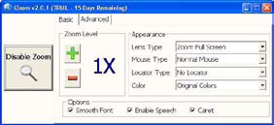 | 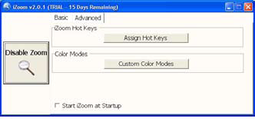

iZoom allows for default or customizable hot keys, several sizes and colors of mouse pointers, color combinations supplied with the program, as well as custom color modes, several sizes and shapes of “locators” that help the user find the location of the mouse pointer, and a choice of several lens shapes, as well as full-screen magnification. iZoom magnifies from 1X to 32X.

The negatives I have found in iZoom are as follows: First, when using the lens mode, you have to place the lens first over what you want to interact with, and then move the mouse pointer within that lens. Second, from about the 3X magnification up, the display becomes more and more pixilated which can be a problem for some vision conditions, such as astigmatism, among others. Third, there is only one voice offered with the speech option and it is not a particularly pleasant one.

As you would expect, with additional options comes an additional cost. Again, you can download a 30-day demo of iZoom from the Website, and if you wish to purchase the program, the price is $199.00. However, keep in mind that the two major commercial screen magnification programs, MAGic from Freedom Scientific and ZoomText Plus from AI Squared, both weigh in at from $300.00 to $550.00, depending on how many options you wish to have. So, if you feel the need to view the bigger picture, give the demos of the above programs a try, and see if they will be of use to you.

This article has been provided to APCUG by the author solely for publication by APCUG member groups. All other uses require the permission of the author (see e-mail address above).

